Annexure3b- Complete filing

INVENTION DISCLOSURE FORM

Details of Invention for better understanding:

1. TITLE: Geo-Tagged Environmental Issue Reporting and NGO-Integrated Eco-Product Marketplace with Incentive-Based Participation System

2. INTERNAL INVENTOR(S)/ STUDENT(S): All fields in this column are mandatory to be filled
A. Full name | _{Shivang Chaurasia}
Mobile Number | 9660967612
Email (personal) | Shiva17ng@gmail.com
UID/Registration number | 12316885
Address of Internal Inventors | Lovely Professional University, Punjab-144411, India
Signature (Mandatory) | 

B. Full name | _{Shivang Chaurasia}
Mobile Number | 9660967612
Email (personal) | Shiva17ng@gmail.com
UID/Registration number | 12316885
Address of Internal Inventors | Lovely Professional University, Punjab-144411, India
Signature (Mandatory) | 
C. Full name | Shivang Chaurasia
Mobile Number | 9660967612
Email (personal) | Shiva17ng@gmail.com
UID/Registration number | 12316885
Address of Internal Inventors | Lovely Professional University, Punjab-144411, India
Signature (Mandatory) | 

A. Full name | _{Shivang Chaurasia}
Mobile Number | 9660967612
Email (personal) | Shiva17ng@gmail.com
UID/Registration number | 12316885
Address of Internal Inventors | Lovely Professional University, Punjab-144411, India
Signature (Mandatory) | 

EXTERNAL INVENTOR(S): (INVENTORS NOT WORKING IN LPU)
A. Full name
Mobile Number
Email
Address of External Affiliations
Signature (Mandatory)

For External Inventors, NOC (No Objection Certificate) from the affiliated institute/university/Industry/lab etc. is mandatory for each individual inventor and their respective topic. For NOC, format is attached below.

(FOR ADDITIONAL INVENTORS, PLEASE ADD ROWS)
3. DESCRIPTION OF THE INVENTION:
The present invention discloses a unified digital platform designed to facilitate real-time identification, reporting, and resolution of environmental issues through a geo-tagged and user-driven approach. The system is developed as a cloud-enabled web and mobile application that integrates location-based reporting, validation mechanisms, incentive distribution, and an eco-product marketplace into a single operational framework.
The platform enables users to report environmental concerns, including waste accumulation, pollution, or animal distress, by capturing images or videos along with precise geographical coordinates using GPS-enabled devices. Each reported issue is processed through a structured verification mechanism involving community participation and, where applicable, authorized organizations to ensure the credibility and accuracy of the submitted information.
An incentive-based participation model is incorporated within the system, wherein users are awarded digital credits for valid and verified contributions. These credits serve as a motivational tool to enhance user engagement and can be utilized within the system’s integrated marketplace. The marketplace is designed to feature environmentally sustainable products developed and supplied by registered non-governmental organizations (NGOs), thereby supporting eco-friendly initiatives and local economic activities.
The invention utilizes key technologies such as geo-tagging, cloud infrastructure, and data management systems, with optional integration of artificial intelligence to improve validation processes and user behaviour analysis. The system is intended for use by multiple stakeholders, including citizens, NGOs, and administrative authorities, creating a collaborative ecosystem for environmental monitoring and sustainable development.
By establishing a direct connection between environmental responsibility, user incentives, and sustainable commerce, the proposed system enhances transparency, encourages public participation, and contributes to long-term environmental sustainability.

- PROBLEM ADDRESSED BY THE INVENTION:

The increasing prevalence of environmental issues such as improper waste disposal, pollution, and animal distress highlights the urgent need for an efficient and accessible reporting and resolution mechanism. In many real-life situations, individuals encounter environmental or humanitarian concerns—such as injured animals, illegal dumping, or hazardous waste—but are often uncertain about how, where, or to whom such issues should be reported. This lack of clarity results in delayed action or complete inaction, despite the willingness of individuals to help.

Currently, there is no unified and user-friendly platform that enables citizens to report environmental problems in real-time with precise location data and supporting evidence. Existing complaint systems are often fragmented, lack geo-tagging capabilities, and fail to provide a seamless mechanism for documenting and submitting on-ground issues effectively.

Additionally, these systems lack transparency and accountability, as users are generally unable to track the progress of their complaints or verify whether appropriate corrective actions have been taken. This reduces user trust and discourages active participation.

Another critical limitation is the absence of an incentive-based participation model. Individuals are not sufficiently motivated to report environmental issues due to the lack of tangible rewards or recognition, resulting in low engagement and underreporting of significant problems.

Furthermore, non-governmental organizations (NGOs), which actively work towards environmental protection and animal welfare, often face challenges in gaining visibility and reaching potential supporters. There is no integrated mechanism that connects citizen-driven reporting with NGO activities or provides a pathway for users to contribute economically to such initiatives.

Existing solutions typically function in isolation, focusing either on issue reporting or on standalone e-commerce platforms, without establishing a meaningful connection between environmental action and economic incentives. This disconnect limits the potential for creating a sustainable and participatory ecosystem.

Therefore, there is a need for a comprehensive system that enables geo-tagged environmental issue reporting, ensures transparent verification, incentivizes user participation, and integrates an NGO-driven marketplace, thereby transforming public concern into actionable impact and sustainable engagement.

- OBJECTIVE OF THE INVENTION (Provide minimum two)
- To develop a geo-tagged environmental issue reporting system that enables users to capture and submit real-time information, including location data and supporting media, for accurate identification of on-field environmental problems.
- To provide a user-friendly and accessible platform that simplifies the process of reporting environmental concerns, thereby encouraging greater public participation.
- To implement a multi-layered verification mechanism involving community validation and authorized organizations to ensure the authenticity and reliability of reported issues.
- To enable an incentive-based participation model that rewards users with digital credits for valid contributions, thereby increasing engagement and consistent reporting behaviour.
- To integrate an eco-product marketplace that allows users to redeem earned credits for environmentally sustainable products offered by registered non-governmental organizations (NGOs).
- To enhance transparency and accountability by allowing users to track the status and resolution progress of reported environmental issues.

C. STATE OF THE ART/ RESEARCH GAP/NOVELTY:
Sr. No. | Existing System / Patent | Abstract | Research Gap | Novelty
 | Government Complaint Applications (example: Swachh Bharat App, Municipal Portals) | Platforms that allow users to report cleanliness and civic issues to authorities. | Lack of incentive mechanisms for users; limited engagement; absence of integrated reward or economic benefit systems. | Introduces an incentive-based participation model where users are rewarded with redeemable credits for verified environmental reporting.
 | Location-Based Reporting Systems (e.g., Google Maps Issue Reporting) | Enables users to report issues with location tagging and basic descriptions. | No structured verification process; no tracking of issue resolution; lacks integration with environmental or social impact systems. | Implements a multi-layered verification system with community and organizational validation, along with transparent tracking of issue resolution.
 | NGO-Based E-commerce Platforms | Platforms selling eco-friendly or sustainable products created by NGOs. | Operate independently without integration with environmental reporting or user engagement systems. | Integrates NGO-driven marketplaces directly with user participation, allowing credits earned from reporting to be redeemed for eco-products.
 | Smart Civic Engagement Platforms | Systems designed to improve citizen-government interaction for issue reporting. | Limited to complaint handling; no linkage between environmental action and economic incentives; low user retention. | Establishes a closed-loop ecosystem connecting environmental reporting, user incentives, and sustainable commerce within a single platform.

D. DETAILED DESCRIPTION:
- System Components and Architecture:
The proposed system comprises a set of interconnected modules designed to enable seamless environmental issue reporting, verification, incentivization, and sustainable product exchange.
- User Interface Module:
A web and mobile-based interface that allows users to register, log in, report environmental issues, track submissions, and access the integrated marketplace.
- Geo-Tagging Module:
Utilizes GPS-enabled devices to capture precise geographical coordinates of the reported issue, ensuring location accuracy and traceability.
- Media Capture and Upload Module:
Enables users to attach supporting evidence in the form of images or videos to enhance the credibility of reported issues.
- Reporting Engine:
Processes user-submitted data, including location, media, and textual descriptions, and stores it within the system for further validation.
- Verification System:
A multi-layered validation mechanism that includes:
  - Community Verification: Other users can review, validate, or flag reports.
  - Authorized Verification: NGOs or designated authorities confirm the authenticity and severity of reported issues.
- Reward Engine:
Allocates digital credits to users based on predefined parameters such as validity, impact level, and urgency of the reported issue.
- User Wallet System:
Stores earned credits securely and enables users to track their reward balance and transaction history.
- Marketplace Module:
An integrated e-commerce platform where NGOs can list eco-friendly and sustainable products, including organic goods and environmentally safe items.
- Redemption System:
Allows users to utilize earned credits to purchase products from the marketplace, creating a direct link between environmental action and economic reward.
- Cloud Database and Backend Infrastructure:
Maintains user data, reports, transaction records, and system operations using scalable cloud-based architecture.
- Working Process:

The operational workflow of the system is as follows:
- A user identifies an environmental issue, such as pollution, waste accumulation, or animal distress, and captures relevant media using the application.
- The system automatically attaches geo-location data to the report using the device’s GPS functionality.
- The user submits the report along with a description and supporting evidence.
- The submitted report is processed by the system and forwarded to the verification module.
- Community users and/or authorized organizations review the report to validate its authenticity.
- Upon successful verification, the system assigns digital credits to the reporting user based on predefined evaluation criteria.
- The earned credits are stored in the user’s digital wallet within the platform.
- The user can access the integrated marketplace and redeem credits to purchase eco-friendly products offered by NGOs.
- NGOs process and fulfil the product orders, completing the cycle of environmental contribution and sustainable consumption.

- Advantages of the Detailed System:

- Ensures accurate and real-time reporting through geo-tagging and media evidence.
- Enhances credibility through multi-level verification mechanisms.
- Encourages user participation via an incentive-based reward system.
- Promotes sustainable products and supports NGO-driven economic activities.
- Establishes a closed-loop ecosystem connecting environmental action with tangible benefits.

E. RESULTS AND ADVANTAGES:
The proposed system provides an effective solution for improving environmental issue reporting and public participation through a structured and incentive-driven approach.
- Improved Reporting Accuracy:
The use of geo-tagging and media evidence ensures that environmental issues are reported with precise location details, making it easier for authorities and organizations to identify and address problems.
- Increased Public Participation:
The incentive-based reward mechanism encourages users to actively report environmental issues, leading to higher engagement and consistent contributions.
- Transparency in Issue Resolution:
Users can track the status of their reported issues, which enhances trust and ensures accountability in the resolution process.
- Support for NGOs:
The integrated marketplace provides NGOs with better visibility and a direct platform to offer eco-friendly products, helping them generate sustainable income.
- Promotion of Sustainable Practices:
By allowing users to redeem rewards for eco-friendly products, the system encourages environmentally responsible behaviour.
- Integrated Ecosystem:
The system connects reporting, verification, rewards, and marketplace functions into a single platform, creating a continuous cycle of environmental contribution and benefit.

F. EXPANSION:
The proposed system can be further enhanced and expanded in several ways to improve its functionality and impact:
- AI-Based Issue Detection:
Future versions can use artificial intelligence to automatically identify environmental issues from images or videos uploaded by users.
- Government System Integration:
The platform can be connected with municipal or government dashboards for faster response and official action on reported issues.
- Blockchain-Based Verification:
A blockchain layer can be introduced to maintain transparent and tamper-proof records of reports and verification processes.
- Smart City Integration:
The system can be integrated into smart city infrastructure for real-time monitoring and management of environmental conditions.
- Expansion of Marketplace:
The marketplace can be extended to include a wider range of eco-friendly products and more NGOs, increasing its reach and impact.

G. WORKING PROTOTYPE/ FORMULATION/ DESIGN/COMPOSITION:
The proposed system is currently in the conceptual and design phase. The overall architecture, workflow, and functional modules have been clearly defined and represented through flowcharts and system design diagrams.
The design outlines the interaction between users, NGOs, and the platform, including key processes such as geo-tagged issue reporting, verification, reward allocation, and marketplace integration. These components have been structured to ensure scalability and ease of implementation.
The system is intended to be developed using modern web and mobile technologies with a cloud-based backend to handle data storage, processing, and user interactions efficiently.
Further development is required to implement and test all modules, including the verification mechanism, reward engine, and NGO marketplace. A complete working prototype is expected to be developed in future stages based on the defined system architecture.

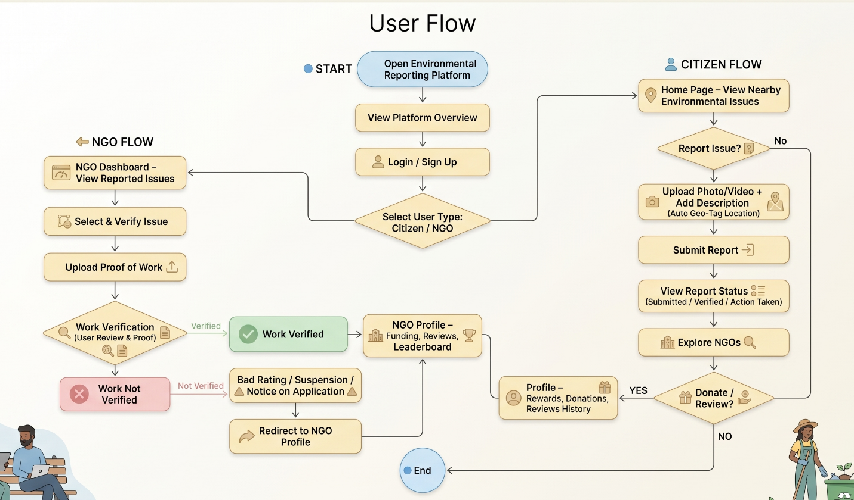

H. COMMERCIALIZATION / MARKET POTENTIAL:
The proposed system has strong potential for commercialization due to the increasing demand for smart environmental solutions and public participation platforms.
With growing awareness about environmental issues and sustainability, there is a rising need for systems that enable easy reporting, transparency, and community involvement. The platform can be adopted by government bodies, municipal authorities, and environmental organizations for efficient issue management.
The integrated NGO marketplace creates additional value by supporting eco-friendly products and sustainable businesses. This opens opportunities for collaboration with NGOs and social enterprises, helping them reach a wider audience.
The system can generate revenue through multiple models such as commission on marketplace transactions, partnerships with NGOs, and integration with government or private environmental programs.
Due to its scalable nature, the platform can be expanded from local implementation to national and global levels, making it suitable for smart city initiatives and large-scale environmental monitoring systems.

I. EXISTING DATA:
No existing dataset has been utilized in the development of the proposed system. The invention is based on real-time, user-generated data, including geo-tagged reports, media uploads, and user interactions within the platform.
All data required for the functioning of the system will be dynamically collected during operation and stored using cloud-based infrastructure for processing and analysis.

4. USE AND DISCLOSURE (IMPORTANT): Please answer the following questions:

- Have you described or shown your invention/ design to anyone or in any conference? | YES () | NO (No)
- Have you made any attempts to commercialize your invention (for example, have you approached any companies about purchasing or manufacturing your invention)? | YES () | NO (No)
- Has your invention been described in any printed publication, or any other form of media, such as the Internet? | YES () | NO (No)
- Do you have any collaboration with any other institute or organization on the same? Provide name and other details. | YES () | NO (No)
- Name of Regulatory body or any other approvals if required. | YES (Yes) | NO ( )

5. Provide links and dates for such actions if the information has been made public (Google, research papers, YouTube videos, etc.) before sharing with us. NA

6. Provide the terms and conditions of the MOU also if the work is done in collaboration within or outside university (Any Industry, other Universities, or any other entity). NA

7. Potential Chances of Commercialization:
The proposed system has strong commercialization potential due to increasing awareness of environmental issues and the growing demand for digital civic engagement platforms. The integration of environmental reporting with an incentive-based model and an NGO-driven marketplace provides both social and economic value.
The platform can be adopted by government bodies, municipal authorities, NGOs, and private organizations for efficient environmental monitoring and community participation. Its scalable design allows deployment from local to national levels, making it suitable for smart city initiatives and sustainability programs.

8. List of companies which can be contacted for commercialization along with the website link.
- Tata Consultancy Services (TCS)
Website: https://www.tcs.com
- Infosys Limited
Website: https://www.infosys.com
- Wipro Limited
Website: https://www.wipro.com
- Reliance Jio Platforms
Website: https://www.jio.com
- Schneider Electric India
Website: https://www.se.com/in/en
- Tata Power – Smart Energy Solutions
Website: https://www.tatapower.com
- Smart City Mission (Government of India)
Website: https://smartcities.gov.in
- SELCO Foundation (NGO)
Website: https://www.selcofoundation.org

9. Any basic patent which has been used and we need to pay royalty to them. NA

10. FILING OPTIONS: Please indicate the level of your work which can be considered for provisional/ complete/ PCT filings (Complete).

11. KEYWORDS:
- Geo-Tagged Environmental Reporting
- Environmental Issue Tracking System
- Smart Civic Engagement Platform
- Incentive-Based Participation System
- NGO-Integrated Marketplace
- Sustainable Product Ecosystem
- Real-Time Issue Reporting
- Environmental Crowdsourcing
- Location-Based Reporting System
- Digital Environmental Monitoring
- Reward-Based User Engagement
- Smart City Environmental Solution

NO OBJECTION CERTIFICATE
This is to certify that University/Organization Name or its associates shall have no objection if Lovely Professional University files an IPR (Patent/Copyright/Design/any other…….) entitled "…………………." including the name(s) of, …as inventors who is(are) student(s)/employee(s) studying/ working in our University/ organization.
Further Name of the University/Organization shall not provide any financial assistance in respect of said IPR nor shall raise any objection later with respect to filing or commercialization of the said IPR or otherwise claim any right to the patent/invention at any stage.

(Authorised Signatory)

